School of Science and Engineering

Division of Engineering Programs

EGG416- Control Theory

Course Design Project

May 5th, 2021

Nikiforos Fokas

Design of a Phase-Lead Controller for a Quadrotor Drone

# Abstract

Table of Contents

Abstract 1

# Introduction

The goal of this project is to develop a closed-loop phase-lead controller to regulate the altitude of a quadrotor drone (shown below in Figure 1). The drone uses four propellors each driven by a DC motor. The control input is the DC current of the propellor motors, the feedback information is the altitude of the drone. To simplify the design the following assumption is made: all four propellers are always synchronized, thus will they always generate the same amount of lift thrust. With this assumption we can ignore any changes in the pitch, roll, yaw, and horizontal movements of the drone.

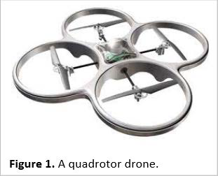

# Theory

# Model Linearization

Due to the weight of the drone the model for the propulsion dynamics is non-linear. The first task (Task 1) is to linearize the model. This is done by calculating the offset values for the current i0, the propeller torque τp0, the propeller angular velocity ωp0,and the lift force F0 that cancels the weight of the drone.

## Task 1

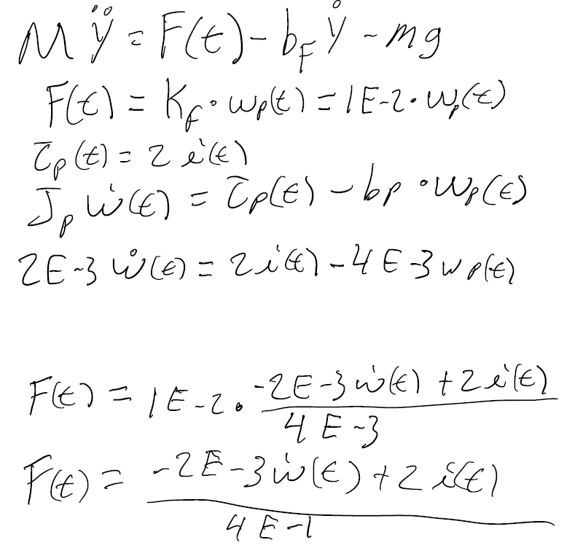

Figure 1: i0 Offset Calculation

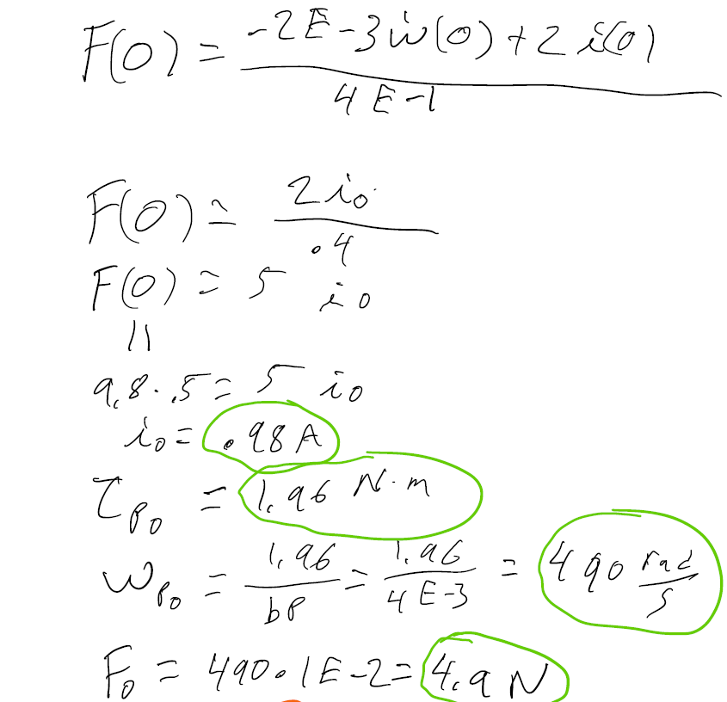

Figure 2: Calculated Offset Values

Table 1: Calculated Offset Values

|  |  |  |
| --- | --- | --- |
| Offset | Value | Units |
| i­0 | .98 | A |
| τp0 | 1.96 | N*m |
| ωp0 | 490 | Radians/s |
| F0 | 4.9 | N |

# Controller Design

The controller is designed based on the Figure(n) below.

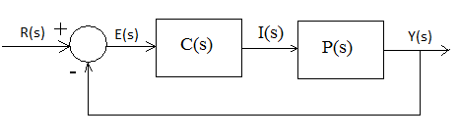

## Task 2

The following figures show the calculations to compute the transfer function of block P(s) in Figure(n).

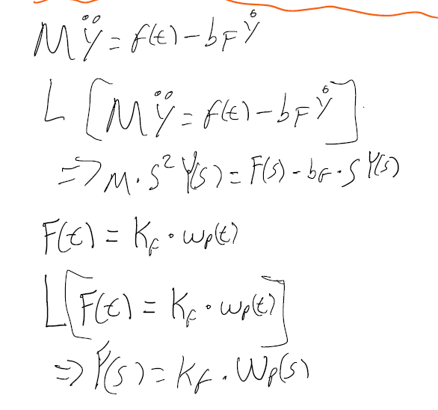

Figure 2: Flight Dynamics Laplace Transforms

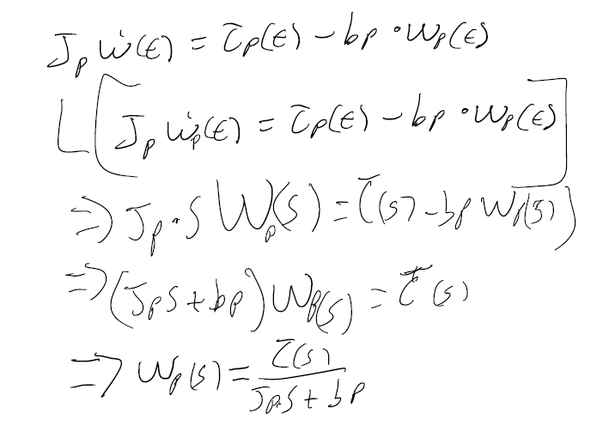

Figure 3: Propulsion Dynamics Laplace Transforms

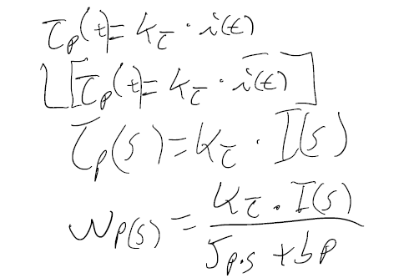

Figure 4: Propulsion Dynamics Laplace Transforms Cont.

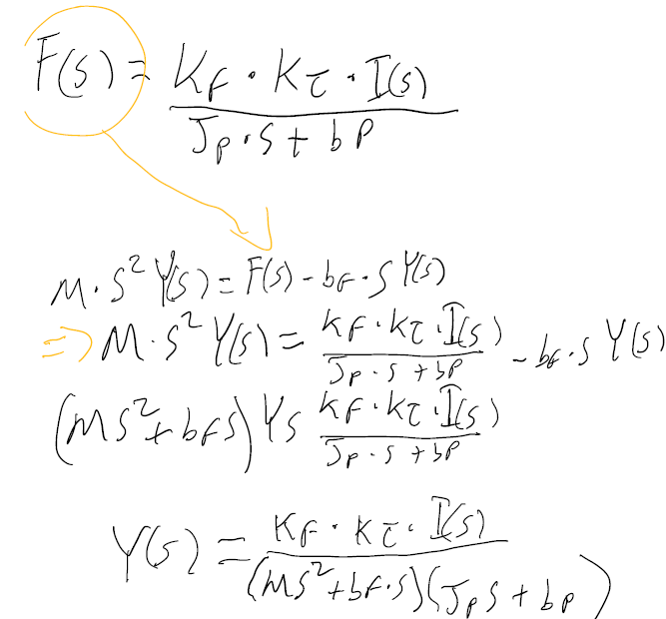

Figure 5: Transfer Function Computation

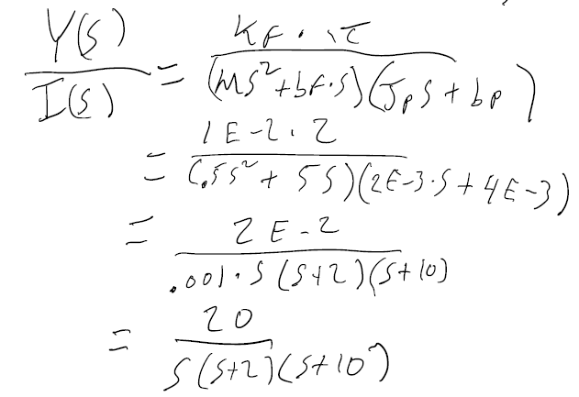

Figure 6: Plant Transfer Function

# Phase-Lead Controller Design

The design specification requires an Overshoot (OS) less than 5%, and a transient time of about 2.5 seconds.

## Task 3

Task 3 is the design process of the phase lead controller (block C(s) in Figure 1) using the Root-Locus (RL) technique and zero-pole cancellation method with the following parameters OS = 4.3, and tt = 2.5 seconds. The calculations Figures….

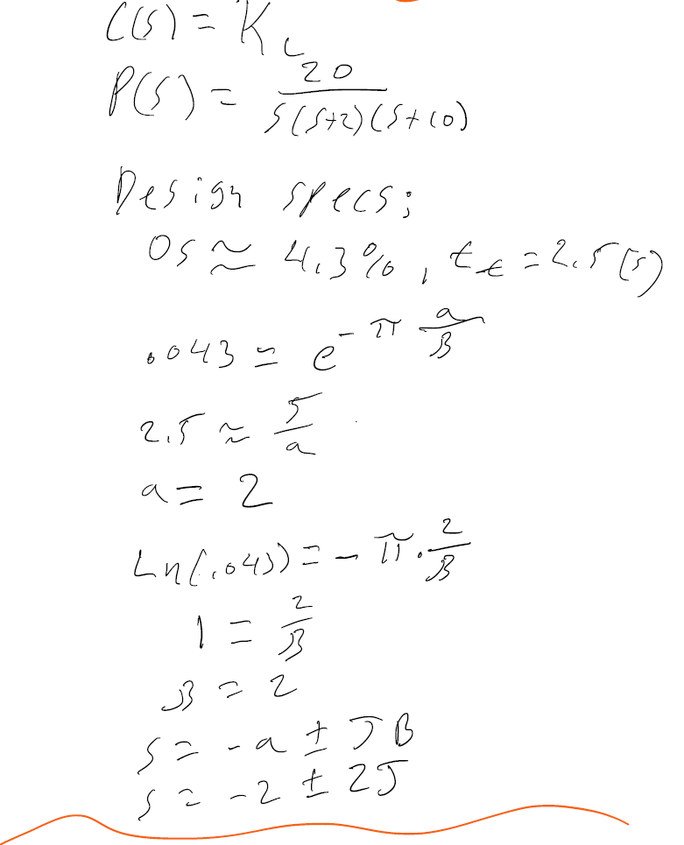

Figure 3.1: Finding the Desired S

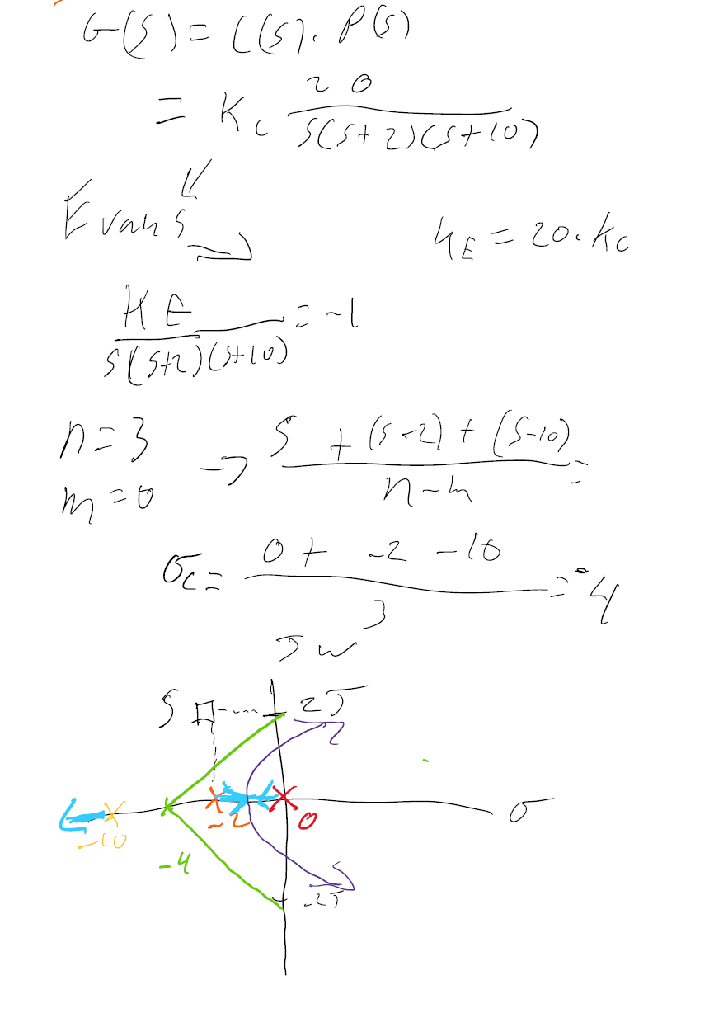

Figure 3.2: Calculation for the RL Plot

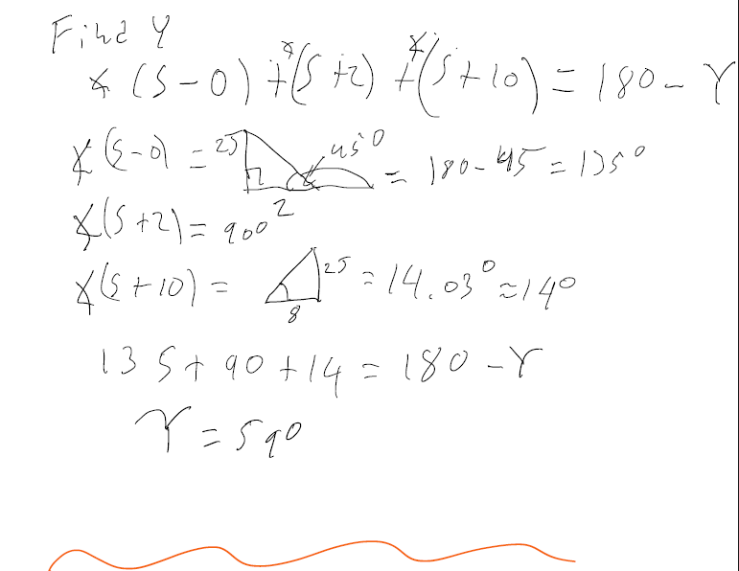

Figure 3.3: Computing the Y for the Angle Condition

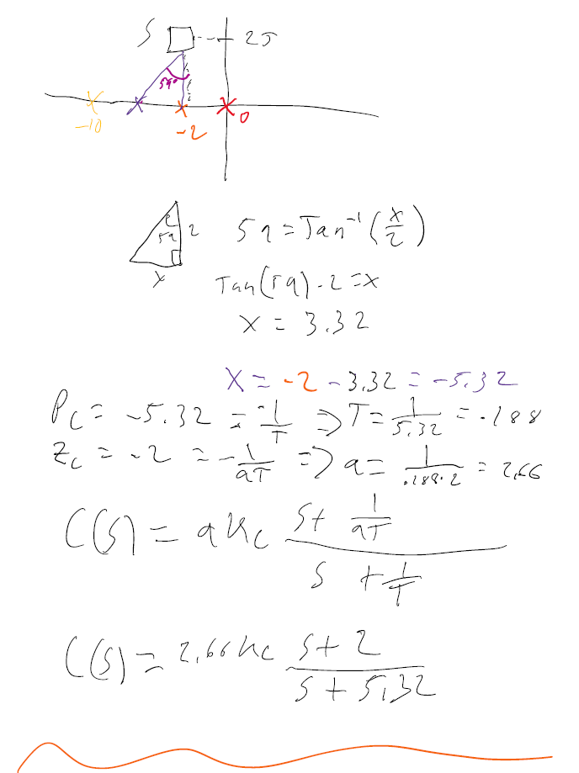

Figure 3.4: Using Y to find a and T for C(s)

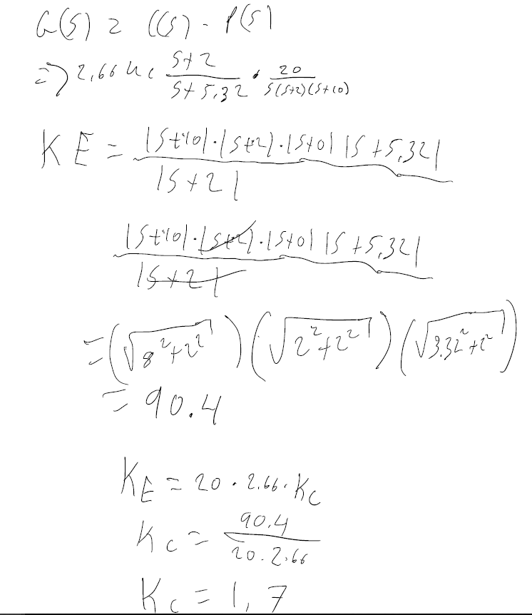

Figure 3.5:Calculating the Controller Gain Kc

Table 2: Calculated Parameters for C(s)

|  |  |
| --- | --- |
| Variable | Value |
| a | 2.66 |
| T | .188 |
| Kc | 1.7 |

### MATLAB Design Verification

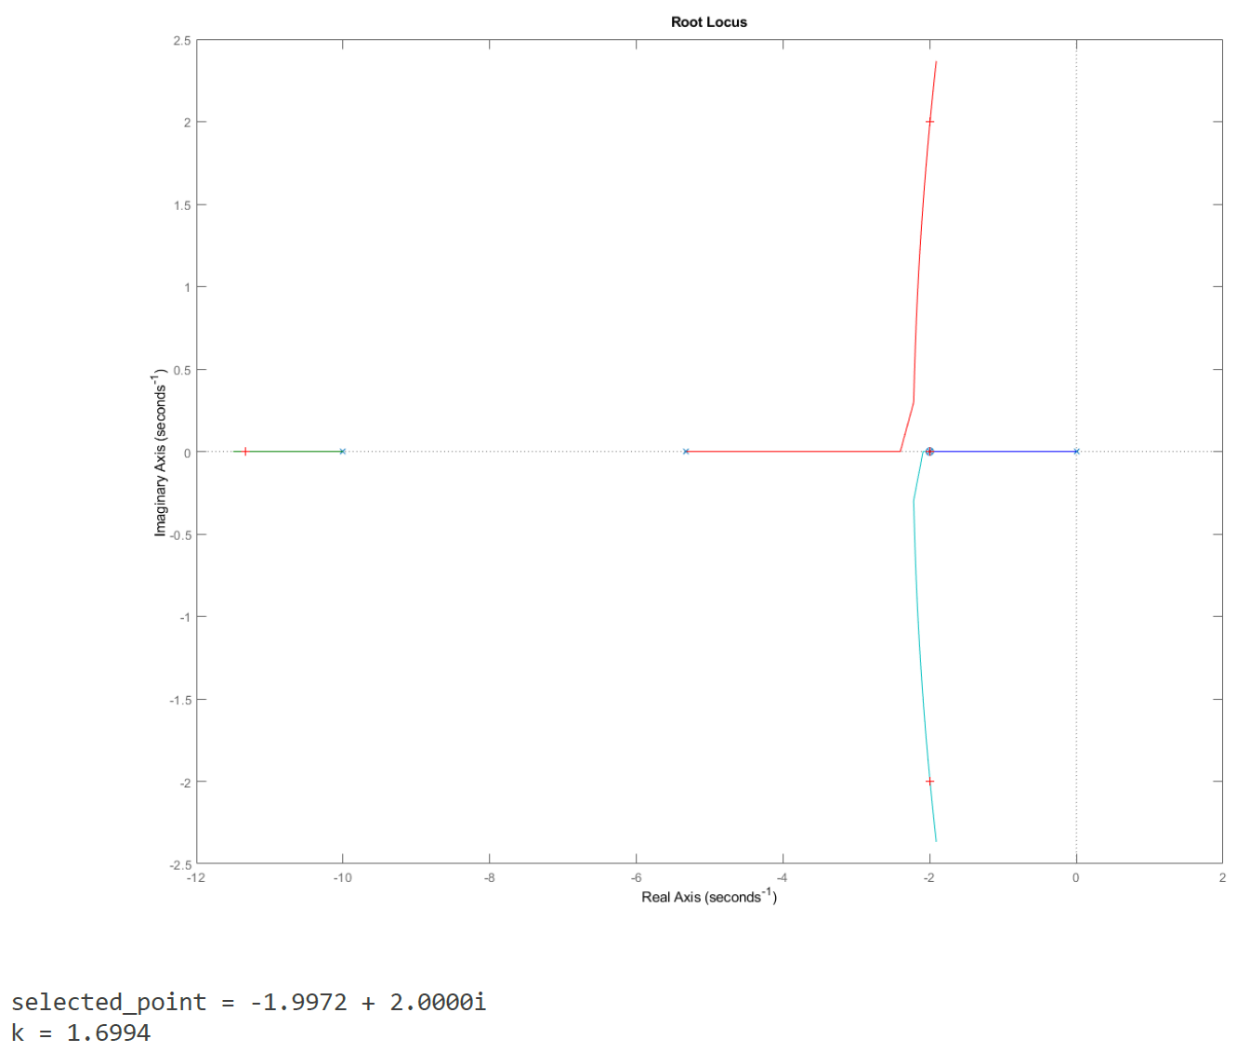

Figure 3.6:Root-Locus Plot with Kc

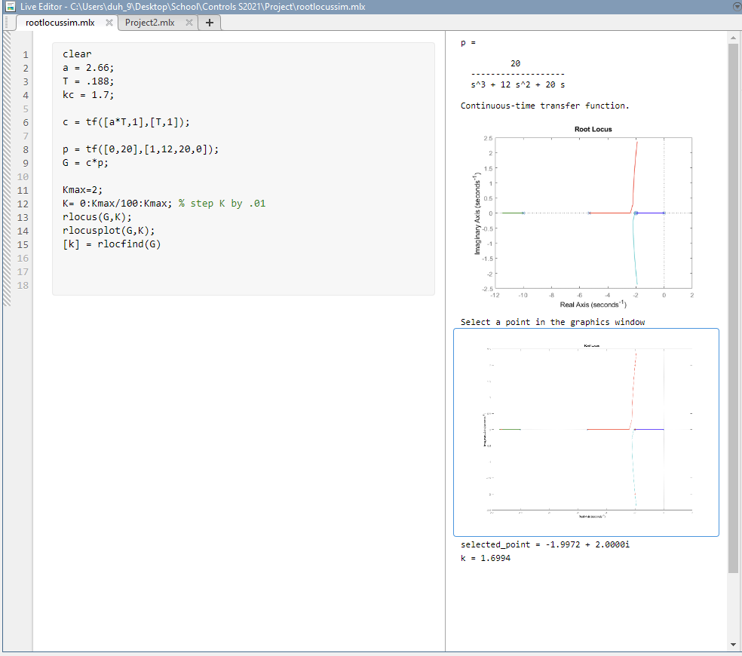

Figure 3.7: MATLAB Code with Output

## Task 4

The final task is to simulate the step response of the completed controller design and compare it to the desired overshoot and transient time.

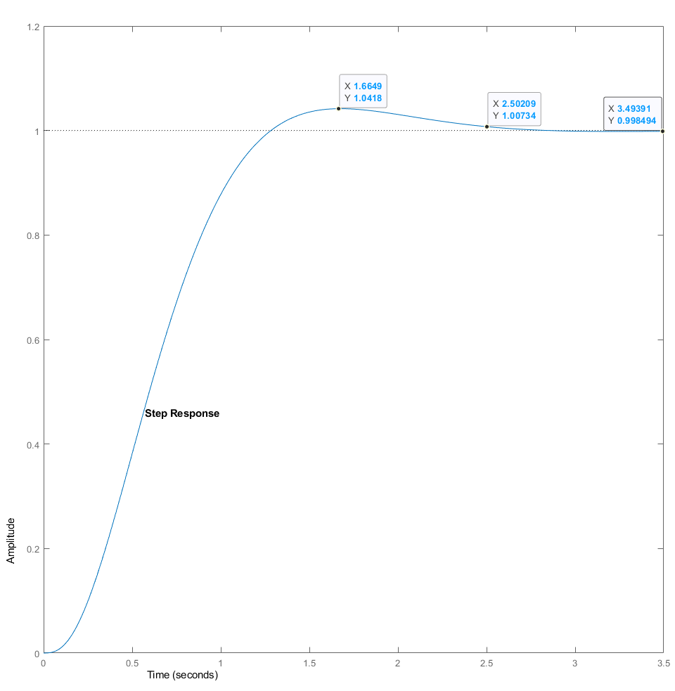

Figure 4.1: Controller Step Response

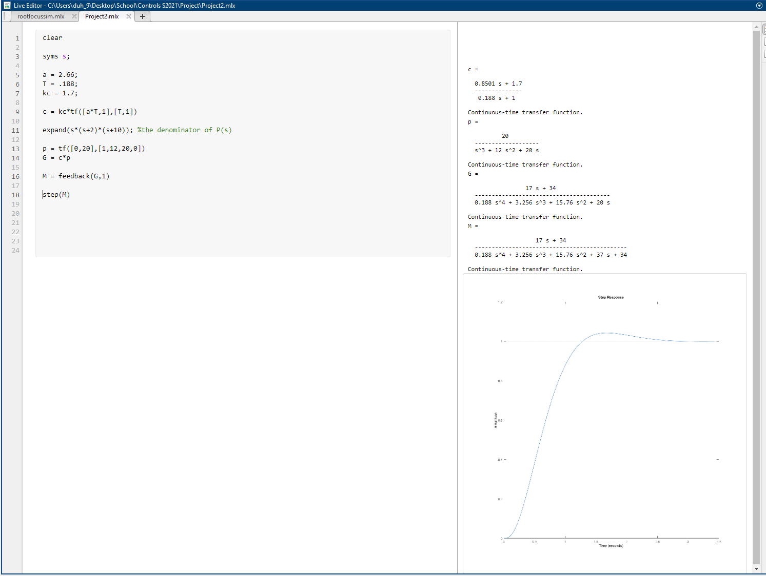

Figure 4.2: MATLAB Code for Task 4

# Conclusion

# References